Pracovní list -anglický jazyk

BUNNY | EGG
1. It is an animal. | 1. It is food.
2. It has got two long ears. | 2. It is coloured.
3. It likes carrots. | 3. It is from a hen.
FLOWER | BASKET
1. It is beautiful. | 1. It is for mushrooms.
2. It smells good. | 2. It is something like bag.
3. It is a birthday present. | 3. It is brown.
BUTTERFLY | CHICKEN
1. It is an animal. | 1. It is a small animal.
2. It is coloured. | 2. It is yellow.
3. It can fly. | 3. It likes corn.
STICK | SHEEP
1. Girls don´t like it. | 1. It is an animal.
2. It is something from | 2. It likes grass.
tree. | 3. It is white.
3. It has got bands.

SLOVÍČKA – VOCABULARY

animal | zvíře
carrot | mrkev
coloured | barevné
food | jídlo
for mushrooms | na houby
hen | slepice
smell good | vonět
birthday present | narozeninový dárek
something like | něco jako
fly | létat
corn | zrní
tree | strom
bands | mašličky
grass | tráva

Pracovní list - anglický jazyk
Vybarvi vajíčka podle zadání:
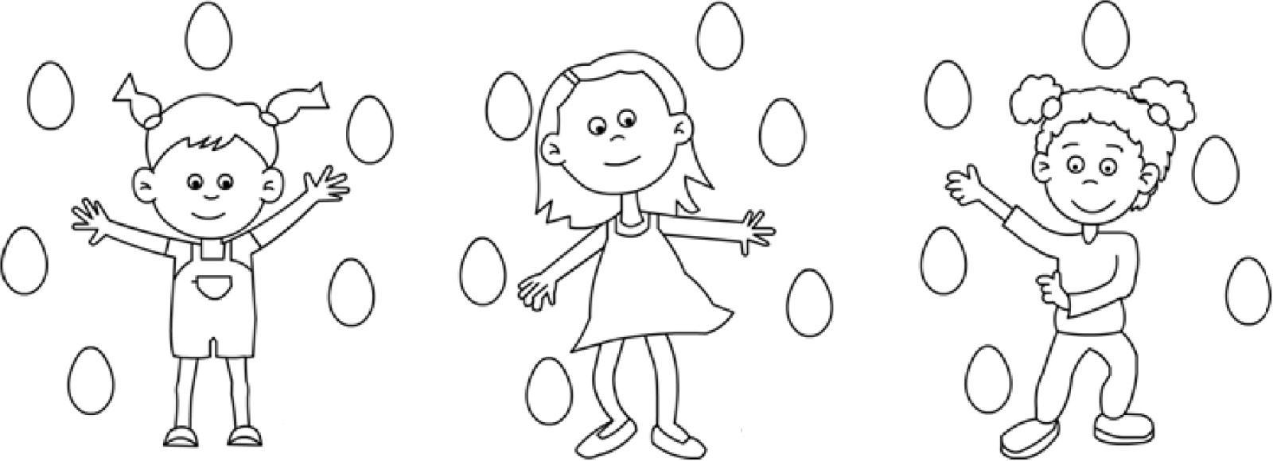

Ann has got two green eggs.

Ann has got one yellow egg.

Ann has got three brown eggs.

Odpověz na otázky:

How many purple eggs has Sue got?

_________________________________________________

How many orange eggs has Nicky got?

_________________________________________________

How many green eggs has Ann got?

_________________________________________________

Sue has got three red eggs.

Sue has got one pink egg.

Sue has got two purple eggs.

Nicky has got one blue egg.

Nicky has got four orange eggs.

Nicky has got one white egg.

